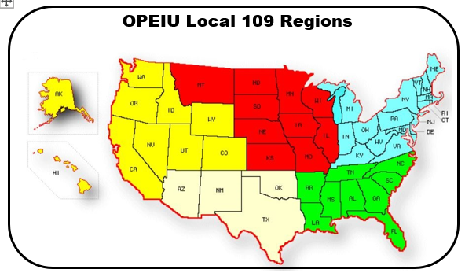

Your region is based on your assigned base location, or, if you have no assigned work site and are a resident of that region.

 | West/Northwest | Kelly Gonzales | (702) 480-5796 | WNWSteward@opeiulocal109.com
 | Midwest | Jason McBryde | (417) 483-1466 | MWSteward@opeiulocal109.com
 | Southwest | Carlos Cuellar | (956) 854-1208 | SWSteward@opeiulocal109.com
 | Southeast | Dennis Worthington | (770) 366-0578 | SESteward@opeiulocal109.com
 | Northeast | Mark Huntley | (434) 989-3589 | NESteward@opeiulocal109.com
President |  | Bobby Kramer | (321) 759-1071 | President@opeiulocal109.com
Vice-President |  | Greg Poore | (602) 770-6581 | VicePresident@opeiulocal109.com
Secretary-Treasurer |  | Mike Ojeda | (606) 261-4433 | Secretary.Treasurer@opeiulocal109.com
Visit the Local 109 Website (www.opeiulocal109.com) on a regular basis.

When registering for the forum please use your real first and last name as the username (if you go by a nickname
that's fine, just not fake screennames like "Rotorjock 24"). Also please do not use your AMC email address.

Local No. 109 Local Steward Roster
Effective: 04/2022
Midwest
IL | Ben Tippets | bdtippets@gmail.com | (510) 590-8439
IL | Michael Litteral | michael.r.litteral@gmail.com | (217) 663-9517
IL | Tad Simpson | pierce219@me.com | (217) 419-6892
IA | Dennis Wood | wood_d@icloud.com | (319) 981-7644
MN | Eric Kroiss | flyingthemagiccarpet@gmail.com | (651) 300-8989
MO | Brandon Nissen | bjnissen5913@yahoo.com | (314) 223-6951
MO | Tony Shaw | Tonyshaw490@gmail.com | (785) 410-2439
NE | Laine Stahr | laine.stahr@gmail.com | (402) 469-5693
Northeast
All | Caden Johnson | helicopterpilot91@yahoo.com | (402) 340-7013
All | Ronald Vasconcelos | tetmes@gmail.com | (678) 350-1131
NJ | Daniel Bonnet | HFS52@aol.com | (609) 309-1572
NJ | Jonathan Jackson | jonjackson1976@gmail.com | (609) 610-5448
DE / MD / PA | Vernon Grier | vernongrier@hotmail.com | (443) 536-1860
PA | John Fetzer | dafetzers@gmail.com | (814) 590-0638
PA | Ronald Scott | rscott5359@gmail.com | (215) 292-5631
VA | Paul Barbee | paulrigus@gmail.com | (919) 609-2415
Southeast
AK | Joe Mayberry | jodean.mayberry@yahoo.com | (530) 941-4563
FL | Jerome Jaynes | jerry.jaynes@gmail.com | (850) 637-0901
FL | Scott Belknap | scottybelknap@hotmail.com | (920) 540-3466
GA | Dennis Quill | Rufuskyote@hotmail.com | (770) 880-3958
GA | Mike Phillips | aecpilot@yahoo.com | (912) 658-5678
GA | Quinn Hunter | qhunter.heli@gmail.com | (801) 885-1619
GA | Wesley Smith | ra5_4@yahoo.com | (770) 653-1306
NC | Dan Andrews | dandrewsz125@yahoo.com | (704) 231-6974
NC | Kevin Kleinpeter | kevinjr2006@yahoo.com | (619) 379-7298
NC | Peter Langer | peterlanger1988@gmail.com | (971) 263-5687
TN | Alan Jewett | alanjewett2002@yahoo.com | (808) 478-0265
TN | Michael Dessinger | flyboydes@yahoo.com | (423) 371-9153
Southwest
AZ | Adam Hom | adam.hom3@gmail.com | (928) 812-2147
AZ | Camron Leuschel | camleuschel@yahoo.com | (858) 213-5943
AZ | David Small | dsmall0316@gmail.com | (928) 301-9670
AZ | Roger Maynulet | mustangscout@gmail.com | (702) 325-2755
AZ | Robert Hanson | robert.helidriver@gmail.com | (928) 242-6434
AZ | Sonny Mercer | sonny.mercer@yahoo.com | (951) 805-3216
NM | Kyle Arnett | kyletarnett@gmail.com | (757) 617-8967
TX | Matt Hagberry | mhagberry@me.com | (303) 241-0050
West/Northwest
CA | James Marchello | jmarchello62@gmail.com | (913) 645-6980
CA | John Holloszy | cfijohnny@gmail.com | (650) 814-0771
CA | Kevin Barber | kevbarbs@yahoo.com | (949) 413-8492
CA | Michael Gallagher | flyingmickey61@gmail.com | (760) 807-0445
CO | Cayce Batterson | cayceatp@gmail.com | (303) 204-0213
CO | Darin Guerrie | darin.guerrie@gmail.com | (970) 640-0424
CO | George Bates | georgewbates@gmail.com | (435) 572-0572
CO | Jeremiah Gardiner | jeremiahgardiner@gmail.com | (605) 393-5346
CO | Shaheed Shabazz | ShaheedShabazz@gmail.com | (910) 545-9620
NV | Dean Mischke | emspilot@sbcglobal.net | (775) 544-7545
NV | Greg Oldham | goflywithme@outlook.com | (909) 553-6902
NV | Will McDonald | bobm33309@gmail.com | (954) 325-8775
WA | Joel Prybylski | joelmpry205@gmail.com | (360) 672-4618

